SCS2209 Database II

[Tutorial 06](https://ugvle.ucsc.cmb.ac.lk/mod/resource/view.php?id=526)

01.

CREATE TABLE Discount(

PurchaseOrderNum int(11) NOT NULL,

PayableWithoutDiscount int(11) NOT NULL,

PayableWithDiscount int(11) NOT NULL

);

DELIMITER //

DROP TRIGGER IF EXISTS DiscountAmount //

CREATE TRIGGER DiscountAmount

AFTER INSERT

ON purchase_order

FOR EACH ROW

BEGIN

INSERT INTO Discount(PurchaseOrderNum, PayableWithoutDiscount, PayableWithDiscount)

VALUES(NEW.Id, NEW.TotalAmount, NEW.TotalAmount*90/100);

END //

DELIMITER ;

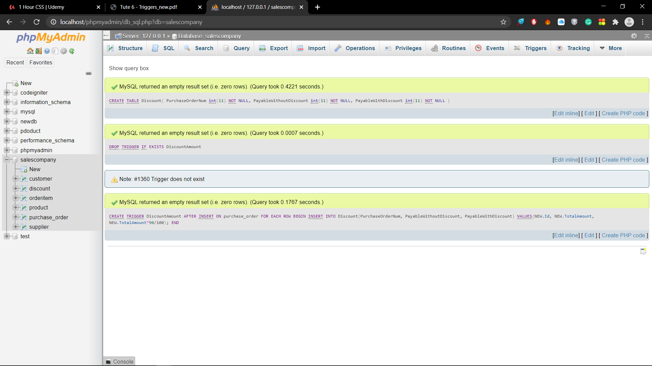

02.

CREATE TABLE TotalAmount(

OrderID INT(11) NOT NULL,

ProductID INT(11) NOT NULL,

UnitPrice INT(11) NOT NULL,

Quantity INT(11) NOT NULL,

TotalAmount INT(11) NOT NULL

);

DELIMITER //

DROP TRIGGER IF EXISTS TotalAmount //

CREATE TRIGGER TotalAmount

AFTER INSERT

ON orderitem

FOR EACH ROW

BEGIN

INSERT INTO TotalAmount(OrderID, ProductID, UnitPrice, Quantity, TotalAmount)

VALUES(NEW.OrderId, NEW.ProductId, NEW.UnitPrice, NEW.Quantity, NEW.UnitPrice*Quantity);

END //

DELIMITER ;

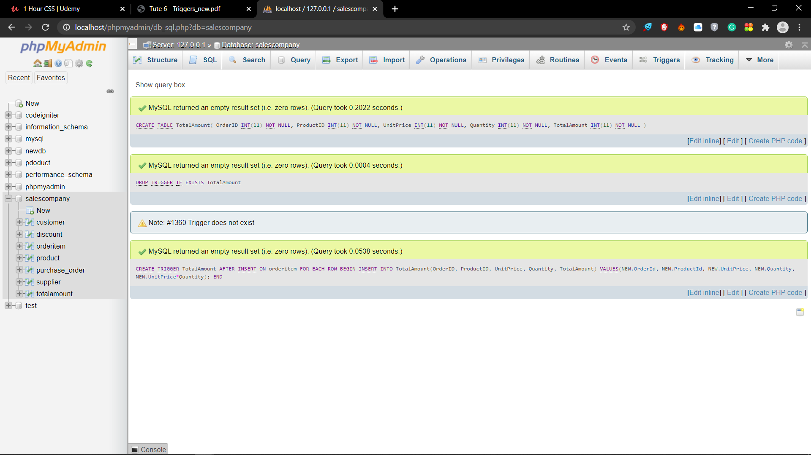

03.

CREATE TABLE Reminders(

Id INT(11) AUTO_INCREMENT NOT NULL,

MemberId INT(11) NOT NULL,

Message VARCHAR(255) NOT NULL,

PRIMARY KEY (Id, MemberId)

);

DELIMITER //

DROP TRIGGER IF EXISTS after_customer_insert //

CREATE TRIGGER after_customer_insert

AFTER INSERT

ON customer

FOR EACH ROW

BEGIN

IF NEW.Phone = NULL THEN

INSERT INTO Reminders(MemberId, Message)

VALUES(NEW.Id, "The Phone number is NULL");

END IF;

END //

DELIMITER ;

